Welcome Guide for Members and Contacts
Welcome to TeamSnap! A few minutes is all it takes to get up and running with your team. These tips for getting started are aimed at players and their fans (parents, guardians, family members).

Accept Your Invitation
- Go to your email and find the TeamSnap invitation from your coach or team manager
- Click the blue Join Now! button
  - If you’ve been invited but can’t find the invitation email, click here and we’ll help you track it down.
- Create a password
  - If you have an existing TeamSnap account under a different email address, click Switch Account to log into the existing account
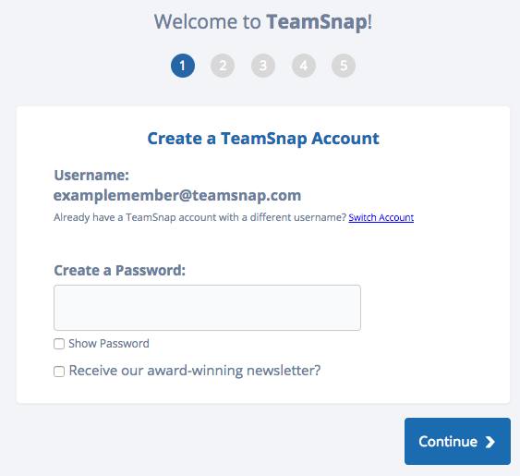
- Click Continue
- Select Yes or No for whether you are accepting for yourself or on behalf of someone else
  - If No, enter your name and relationship to the player
- Click Continue
- Enter your mobile number and select your provider if you'd like to receive team alerts to your mobile device
  - Tip: If you don’t want to share your number with teammates, check the box next to “Make Private.” Coaches and team managers will be able to see phone numbers even if this box is checked.
- Click Continue
- Select Yes or No for adding family member access to your account
  - If Yes, complete the remaining fields for family member information
- Click Continue
- Click Take Me to my Team! and you are all set!

Access Your Team Site
Once you've connected with your team, accessing the team site from the My Teams dashboard is as easy as one click (once you're logged in)!
- Log in at go.teamsnap.com
- Go to the My Teams section of your TeamSnap dashboard
- Click on your roster name below the team name to gain access to the team site under the appropriate roster profile
If you have multiple profiles on a team, this gives you quick access to interact with the team using the selected roster profile.

Set Your Notification Preferences
- Log into your TeamSnap account
- Click your team name under My Teams in your TeamSnap Dashboard
- Click the Preferences tab
- Set your preferences for how you'd like to receive alerts. We recommend leaving the settings as they are, but you can always adjust things like how far in advance you receive game reminders.
